**Project Study For**

**IITCE**

**(Institute Management System)**

**Date: 21-03-2020 (Saturday)**

This project study is for Institute management system that is being developed by DoonDevelopers for IITCE haridwar.

I have received screenshots from the owner of IITCE from which I am making conclusions for this proposed software (Web Application)

The following list is the main features that are demanded by this software these points must be considered in mind while developing this web application.

**INDEX**

1. Masters
   1. Streams Master
   2. Fee head Master
   3. Course Master
   4. Affiliation body Master
   5. Course fee setup
   6. Discount scheme setup
   7. Batch Master
   8. Reference Master
   9. Employee Master
   10. Configuration
   11. Exit

**Detailed Info for Masters**

1. **Masters**

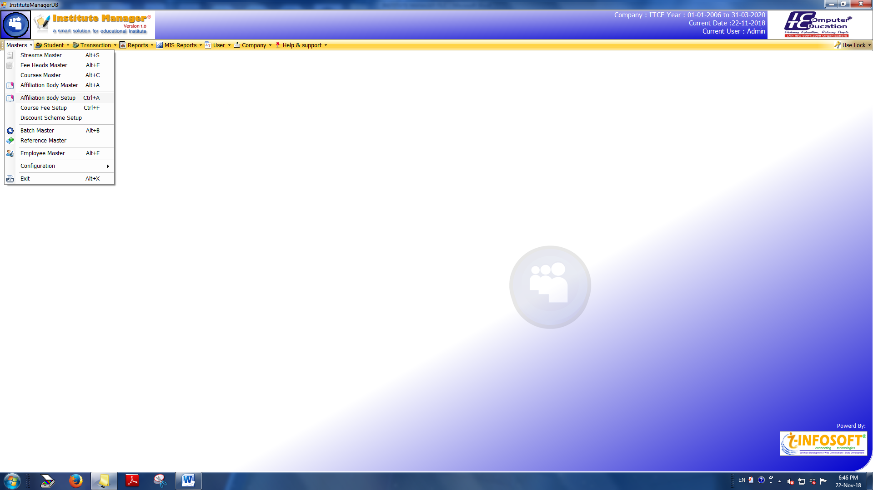

This section is mainly concerned with the admin and must deals with all the basic components as this web application such as creating/defining Courses, Fee Structures, Stream, Batches etc.

* 1. **Streams Master**

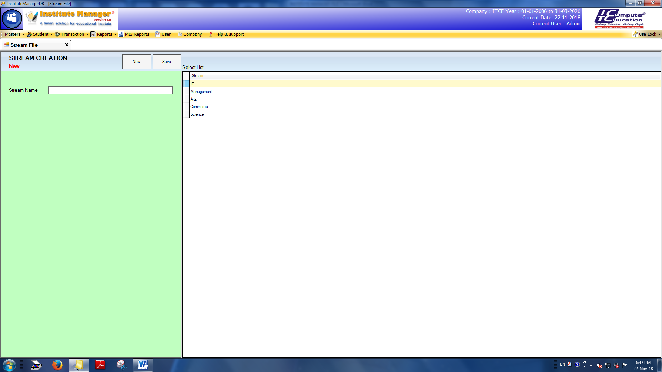

The stream master section is basically responsible for the creation of Streams that are further used for Creating Courses by allotting those streams to them.

For an example Streams can be Science, Arts, Commerce, and IT etc.

* 1. **Fee head Master**

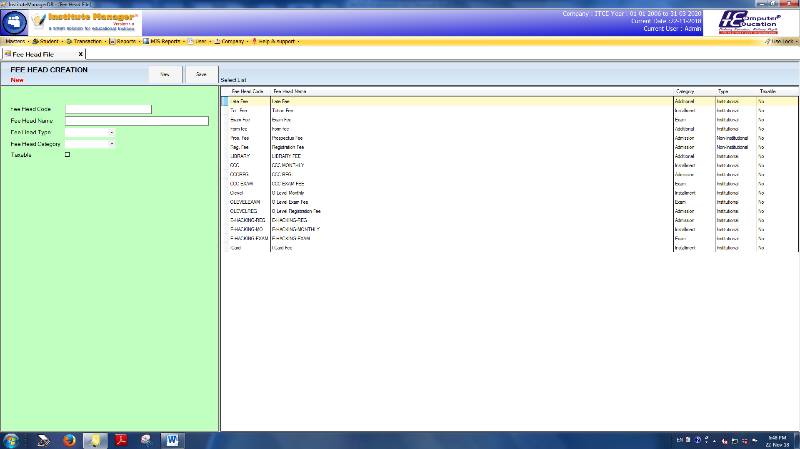

Fee head master is basically for creating different criteria or sections. Based on these sections or heads different fee structures are created, the fee header master requires the following data to create a fee head.

1. Fee head code (That’s printed on the Fee Slip)

2. Fee head Name

3. Fee head Type [Institutional/ non-institutional/ refundable] - can be added on the spot

4. Fee head Category

5. Taxable [Yes/No]

* 1. **Course Master**

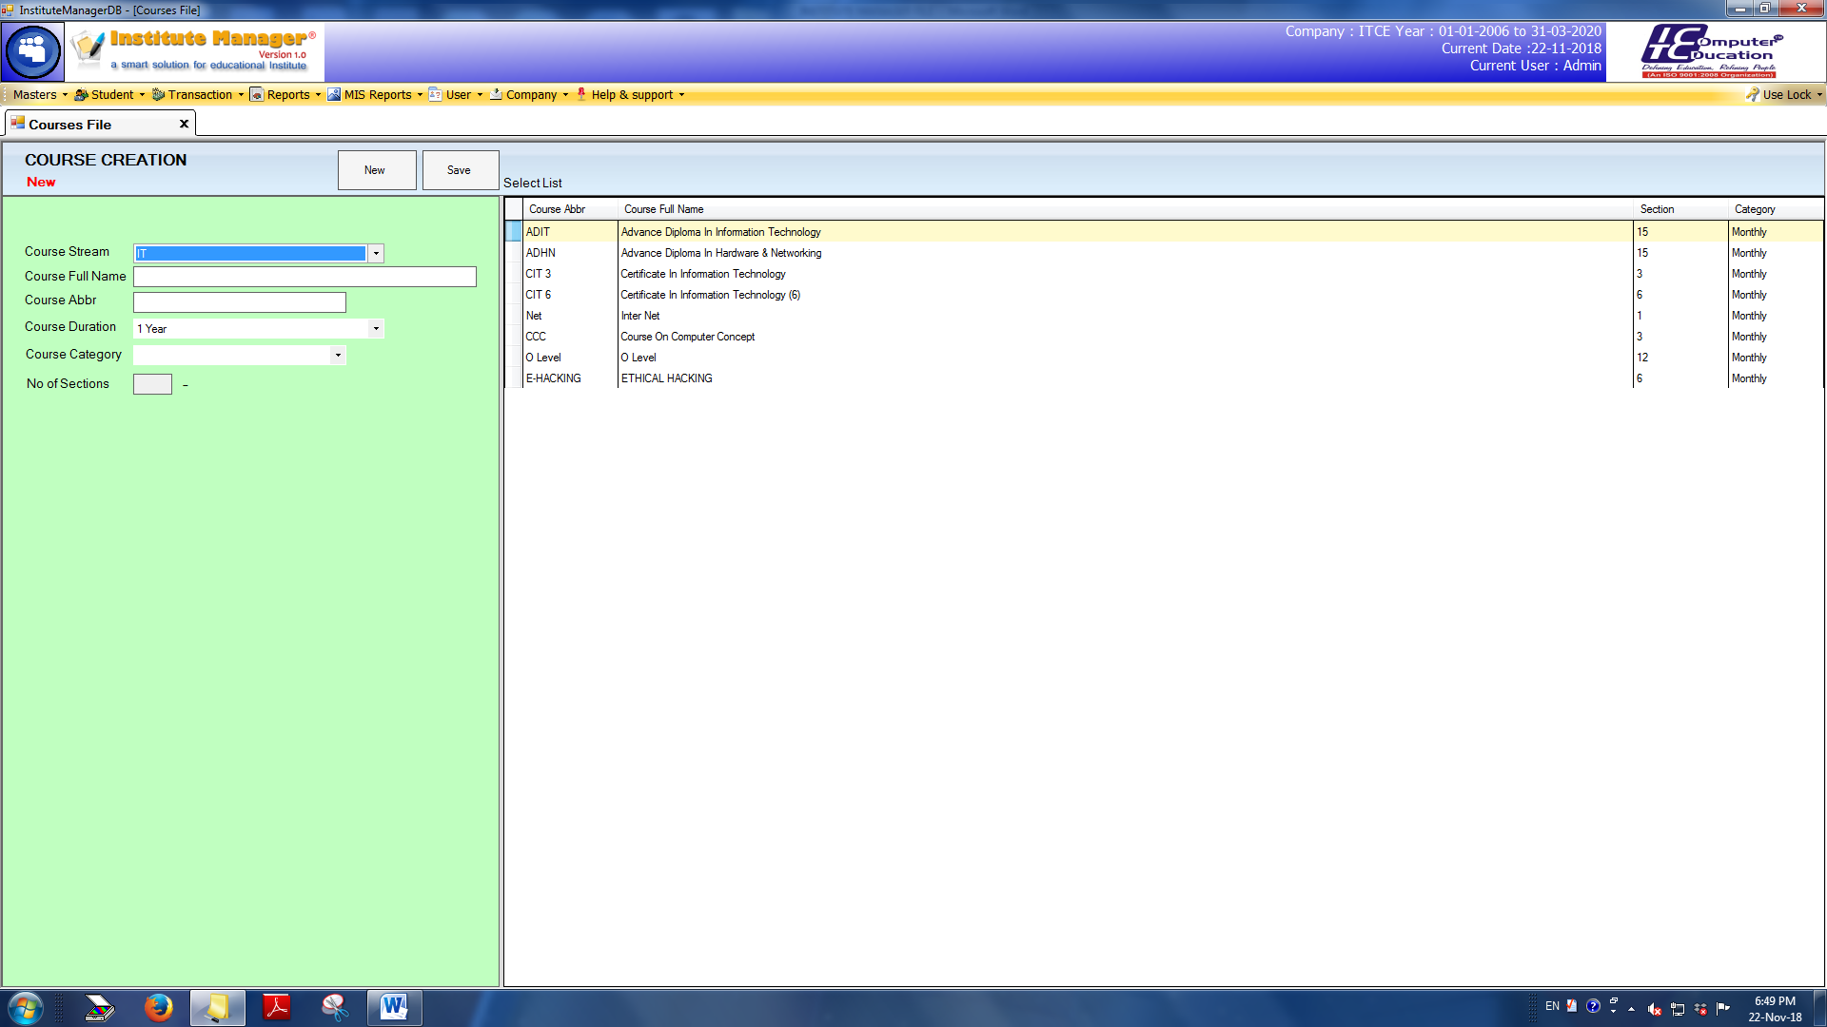

Course Master as the name suggests is the section where Courses for the institute are defined and managed. This Section will require the following input as to create a new course.

1. Course Stream – That is defined earlier
2. Course Full Name
3. Course Abbreviation Name
4. Course Duration
5. Course Category [exclude this option]
6. No. of Sections [exclude this option]
   1. **Affiliation Body Master**
   2. **Affiliation Body Setup**
   3. **Course Fee Setup**
   4. **Discount Scheme Setup [exclude]**
   5. **Batch Master**

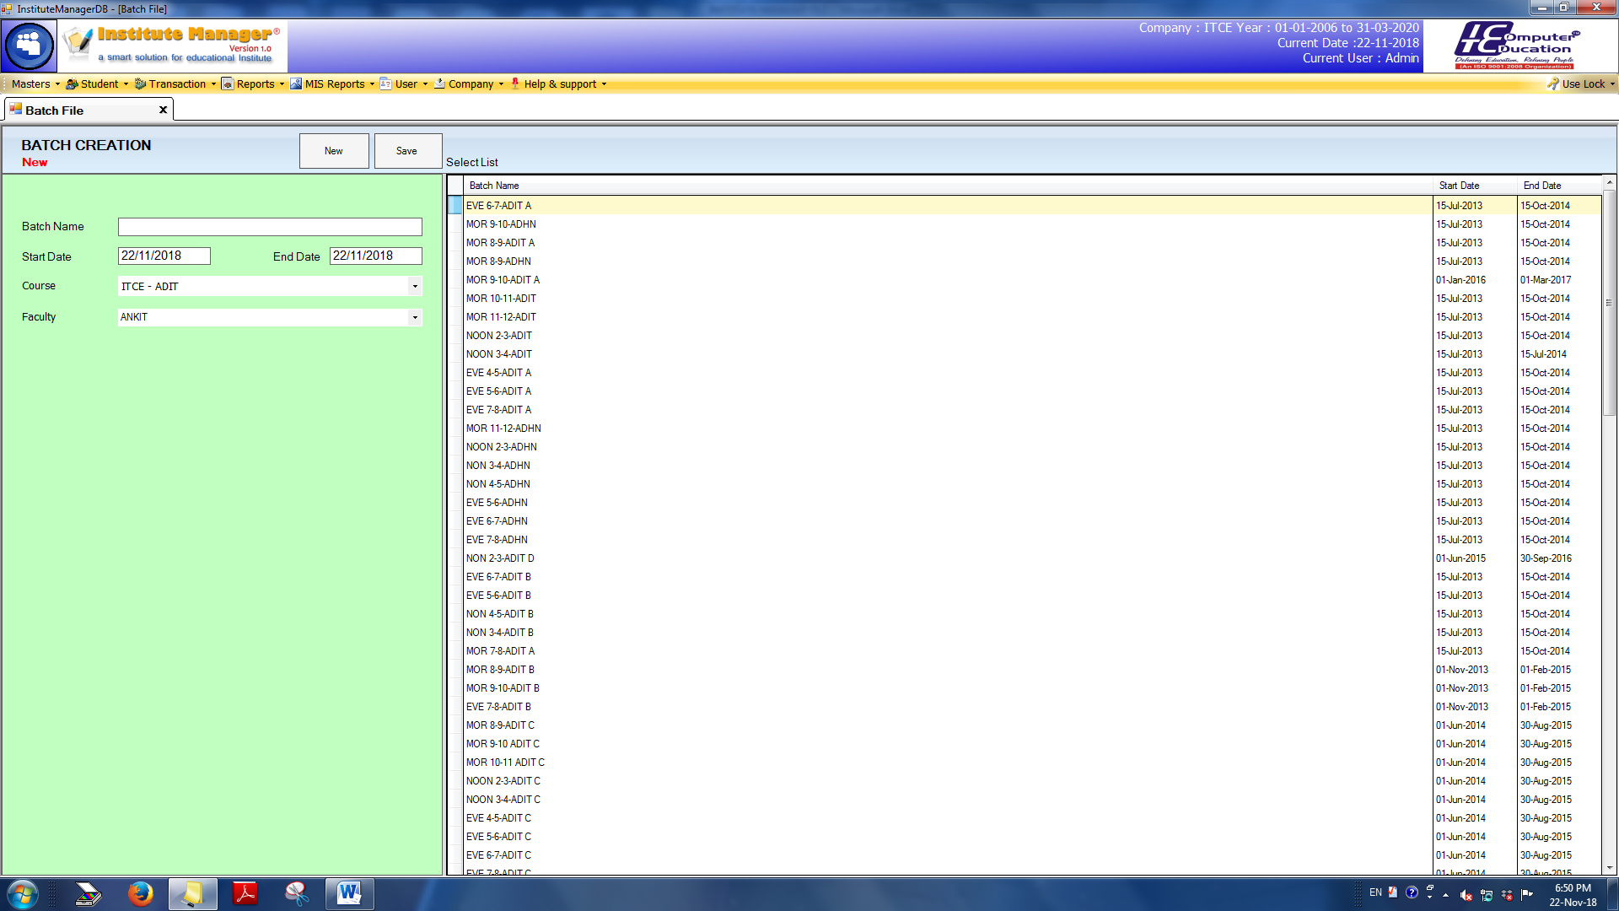

Batch master is basically for creating different batches for the institute based upon different courses and different time spans with a faculty being allotted to the batch.

Creating a batch requires the following info.

1. Batch Name

2. Start Date

3. End Date

4. Course

5. Faculty

* 1. **Reference Master**

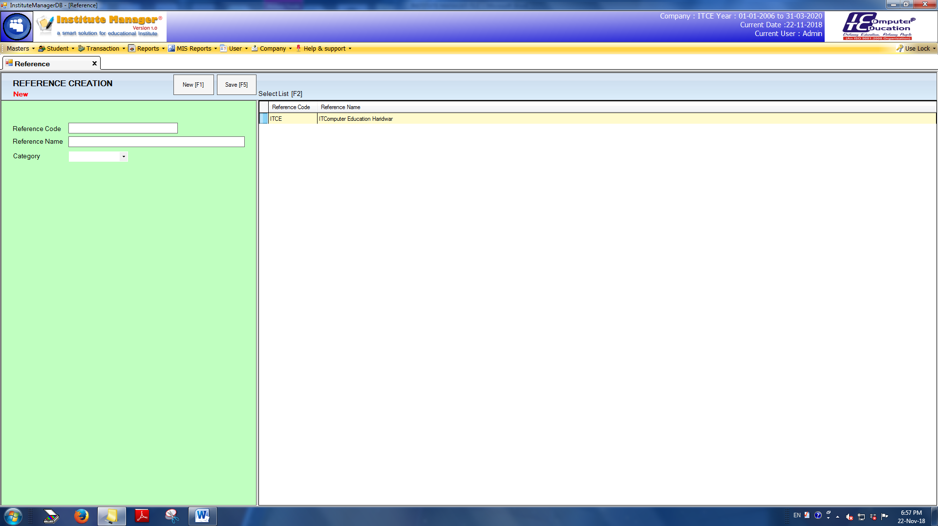

Reference Master is basically an entry that will track the source of the student that the student is generated from. Reference creation will be done on the following bases:

1. Reference Code

2. Reference Name

3. Category

* 1. **Employee Master**

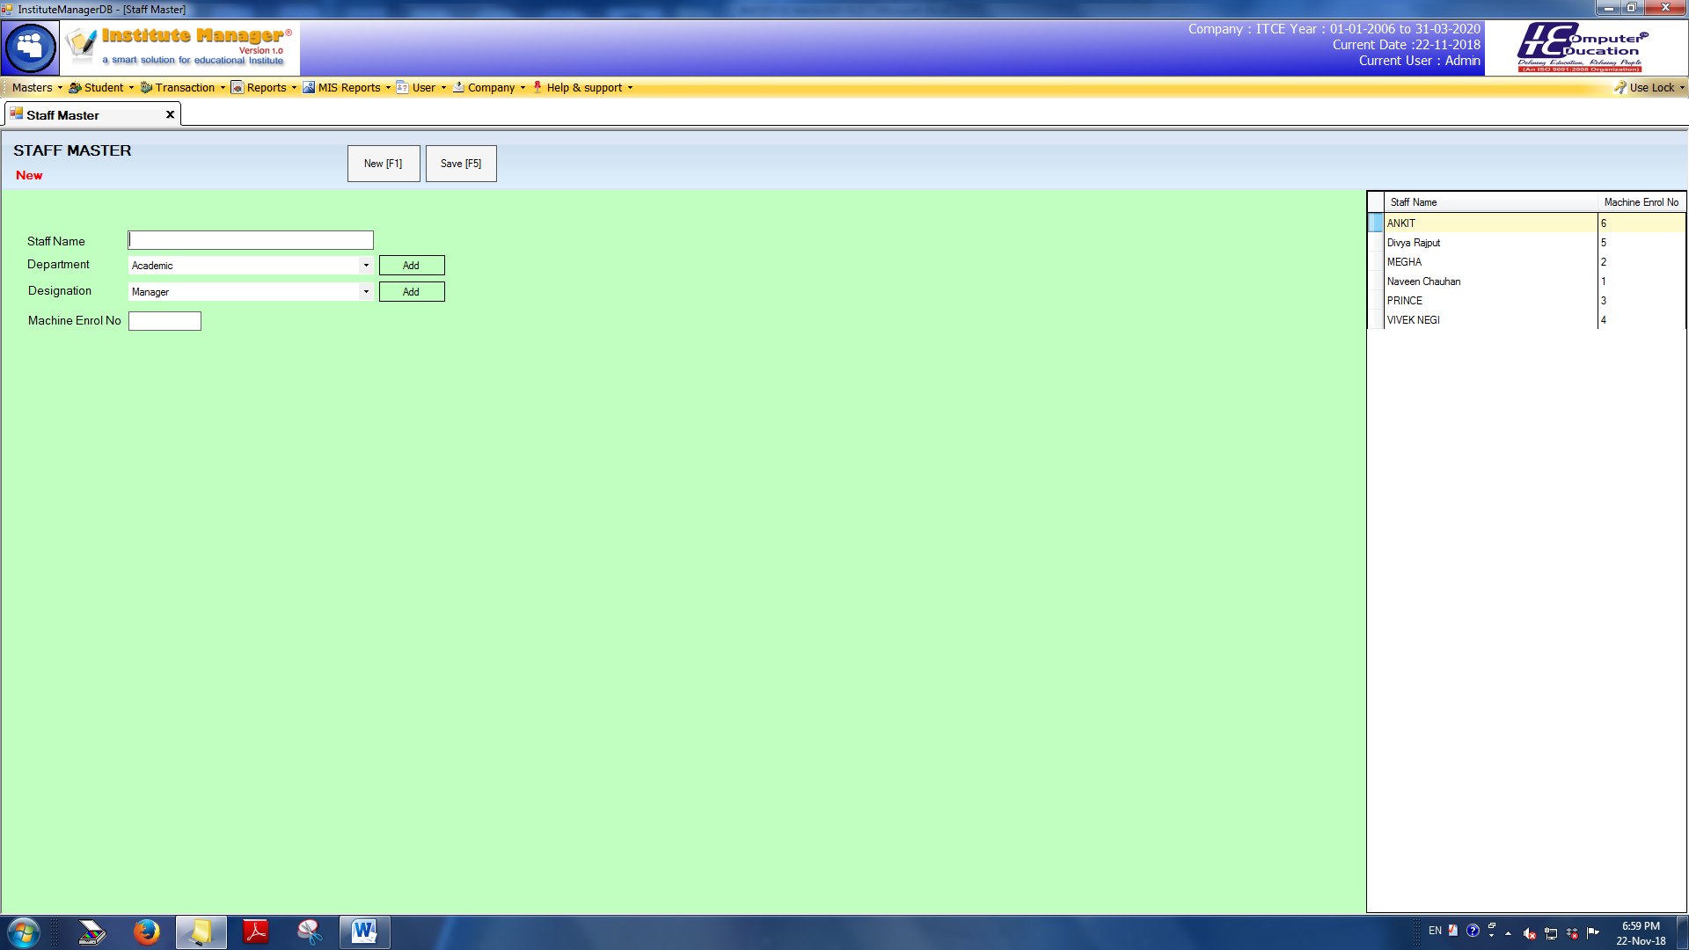

This section will be used for creating new employees based upon the following information’s:

1. Staff Name/ Employee Name

2. Department [that can be added on spot or with a select dropdown]

* 1. **Configuration**
  2. **Exit / Logout**